The Virtual PULSR Environment
- Description: A simple 2D path tracking environment where an agent (black box) follows the red ball through the boundaries of the circle in a complete revolution. The goal is to find the shortest trajectory of a complete revolution while maintaining close proximity to the red ball.
- Physical Outlook

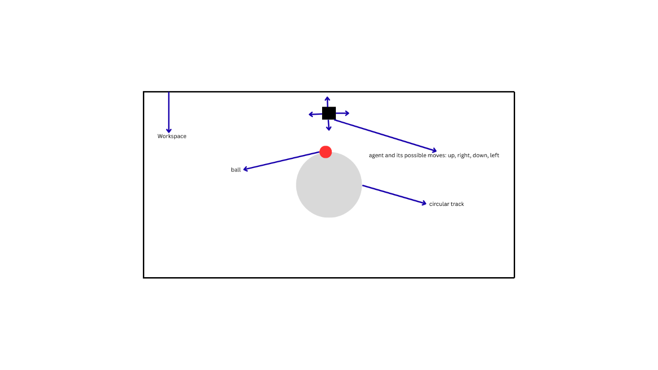
- State Space: x coordinate, y coordinate and score {score +=1 if d <=70, where d is the Euclidean distance between the agent and the ball}.
- Observation Space: Same as State Space.
- Action Space: Up, Right, Down, Left ("N", "E", "S", "W"). If the agent hits the workspace boundary, it will reverse the initial step and find a new path.
- Reward Function:
Final Score of the Episode | Reward
>150 | 3
100 – 150 | 2
90 – 100 | 1
90 | 0
70 – 90 | -1
50 – 70 | -2
<50 | -3

Reward Per Step = -3 / 239 approximately -0.01255 (negative because it is trajectory optimization task)
- Environment Dynamics: If d >=a, the agent chooses actions randomly from the action space until d <=a. Choose a = 50 for start but change, if need be, to optimize score.

